|  |  |
| --- | --- |
| D:\PAL\Logo_4_21_15\Logo_4_21_15\Primary Logo\png_files\EPAM_LOGO_Full_Color_RGB.png | CDP Automated Testing Mentoring Program  2017-Q2 |

MODULE 6.1: test reporting with .net libs REPORT BY ALIAKSANDR NESTSIARENKA

## acceptance criteria

1. Format of logs is informative (contains info about log level, time (e.g. YYYY-MM-DD hh:mm:ss,SSS), string of log, etc)
2. Different log levels are used (debug, info, action, warning, error)
3. By default logs are written in console and are stored in file (a file should be created automatically – a new one for a new date)

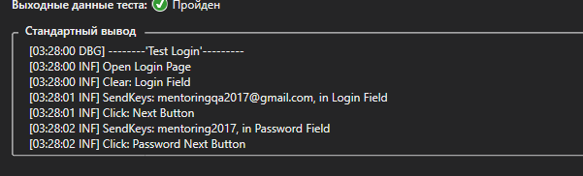

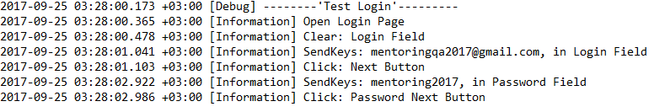

1. In case of tests are failing – there is ability to save screenshot of a failure in a directory. The log should have information about the saved screenshot in this case

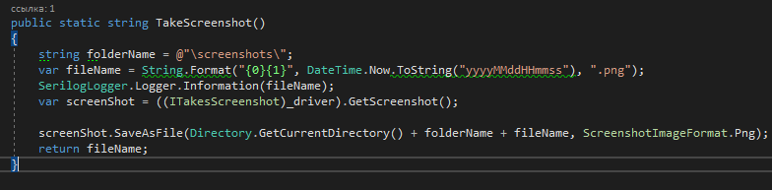

1. Test execution report is created for each run (the sample of the report should be provided as an artifact to a mentor)